Assignment 4.1
A technical document that is easy to use: Project Documentation
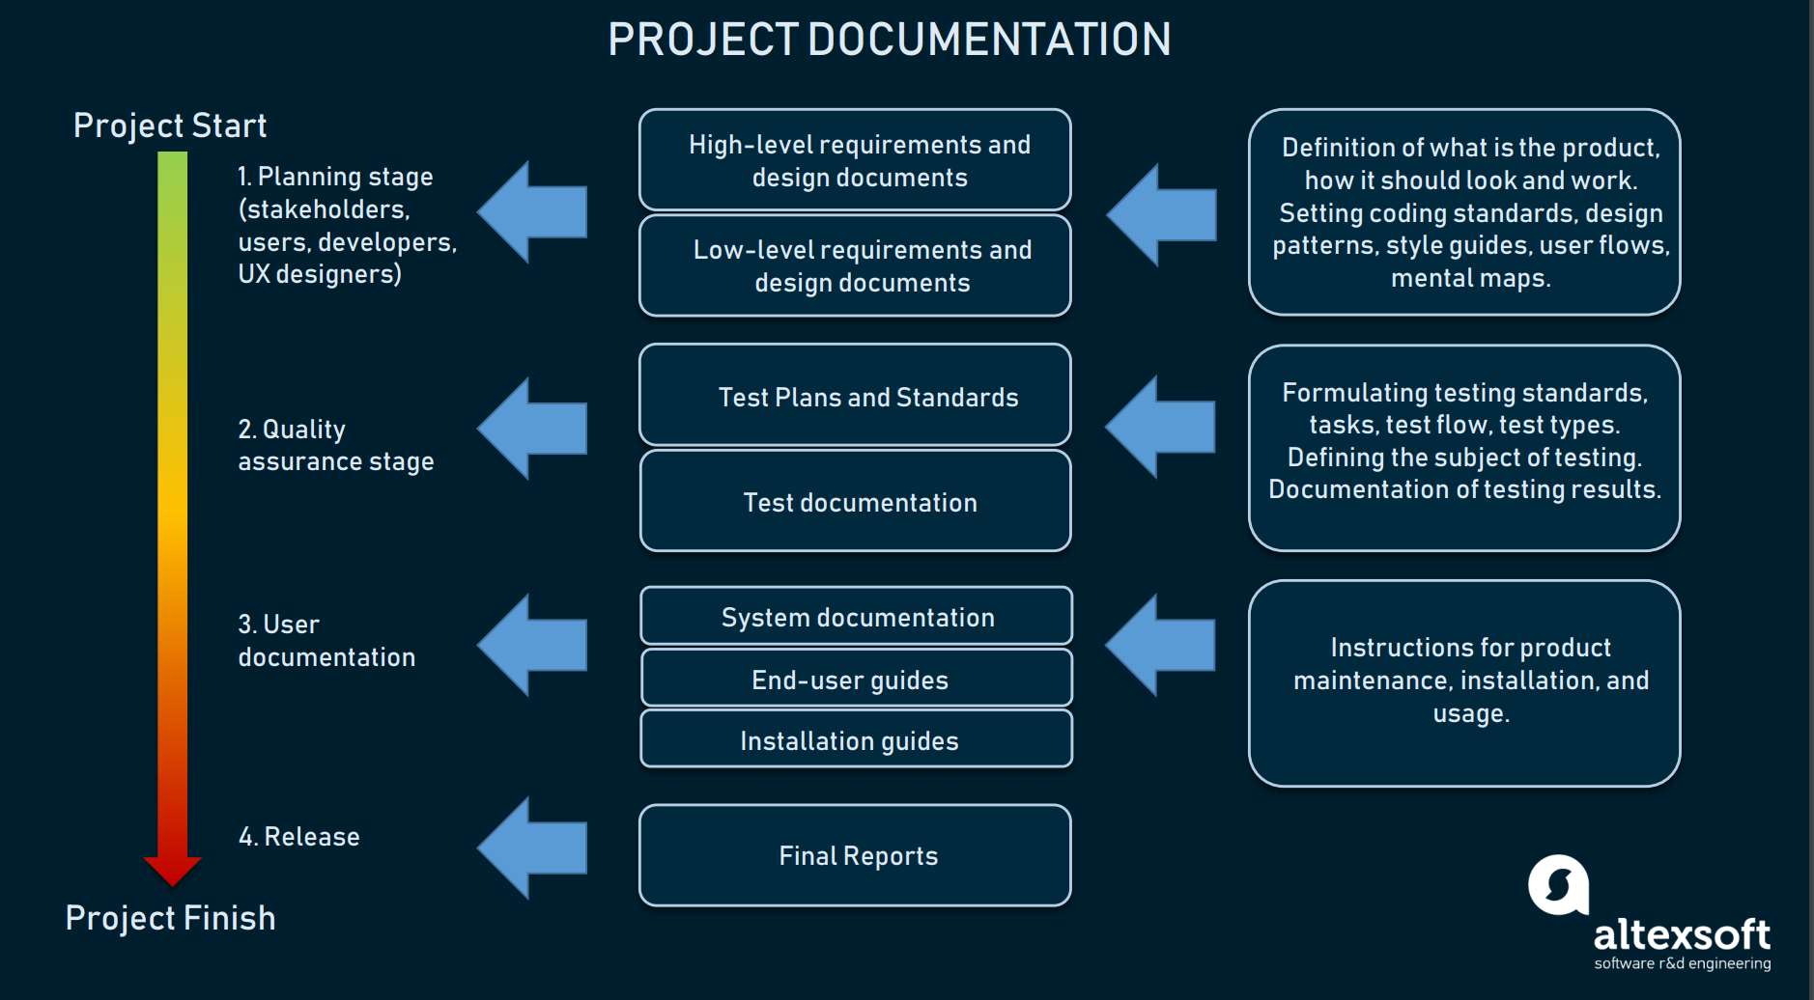
Characteristics of the document that makes it usable: Accuracy of the content is one of the features that makes this document usable. It is apparent that this document entails simple sentences that lack any form of error. It implies that the readers can easily read and understand what the document highlights without confusion. This document is also easy to use because it entails a perfect organization of its content. For instance, there is a proper arrangement of the project requirements from the start-up to the finishing stage.

A technical document that is hard to use: A technical document in software development.
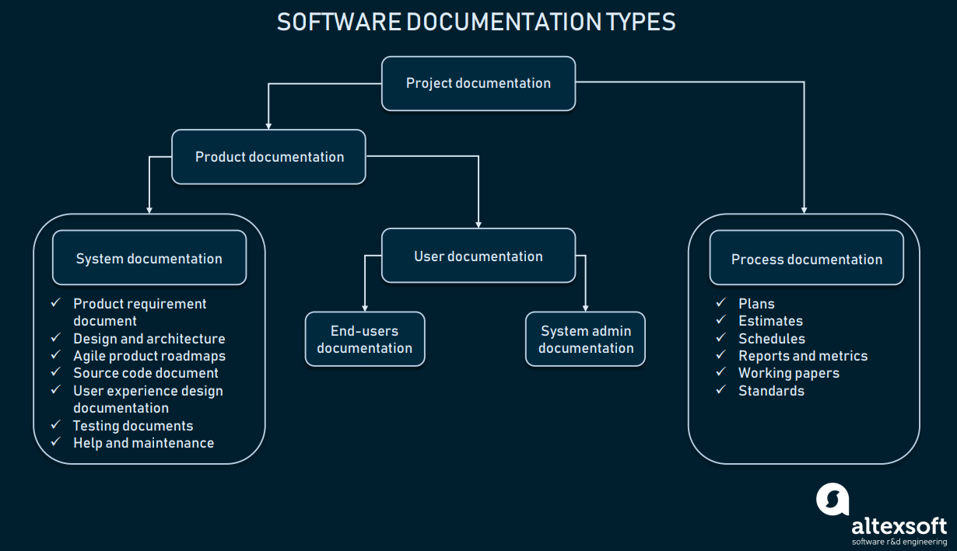
Characteristics that make the document hard to use:
One of the characteristics that make this document hard to use is that it is written in ambiguous words. Some of these words are hard to understand. This means that an individual is required to define these concepts before putting the document to use.

Memo
Date: March 20, 2021.
To: Instructor
From: Ahmed
Subject: Fixing the unusable document
This technical document in software development can be revised in order to improve its usability. One of the techniques that can be utilized to make this document usable is through using simple terms. I would replace the ambiguous terms with simple terms that the audience can easily read and comprehend. I would also include a section of the definition of terms to enable readers to understand every hard or unfamiliar concept when using the document.

